RESOLUTION NO.__________

RE: CERTIFICATE OF APPROPRIATENESS UNDER THE
PROVISIONS OF THE ACT OF THE PENNSYLVANIA
LEGISLATURE 1961, JUNE 13, P.L. 282 (53
SECTION 8004) AND BETHLEHEM ORDINANCE NO.
3952 AS AMENDED.

WHEREAS, it is proposed to re-roof the front roof portion and the two dormer roofs at 25 E. Wall Street.

NOW, THEREFORE, BE IT RESOLVED by the Council of the City of Bethlehem that a Certificate of Appropriateness is hereby granted for the proposal.

Sponsored by:_

_

ADOPTED BY COUNCIL THIS DAY OF , 2016

President of Council

ATTEST:

City Clerk

HISTORICAL & ARCHITECTURAL REVIEW BOARD

The applicant proposes to re-roof the front porch portion and the two dormer roofs at 25 E. Wall St.
APPLICATION #2:

Jim McIntosh
25 E. Wall St.
Bethlehem, PA 18018

OWNER:

__________________________________________________________________

The Board upon motion by Phil Roeder and seconded by Nancy Shelly adopted the proposal that City Council issue a Certificate of Appropriateness for the following:

- Roofing to be GAF Slateline Antique Grey shingles.

2. Valley flashing to be to be black aluminum.

3. Drip edges are to be cream colored.

4. The motion was unanimously approved.

__________________________________________________________________________

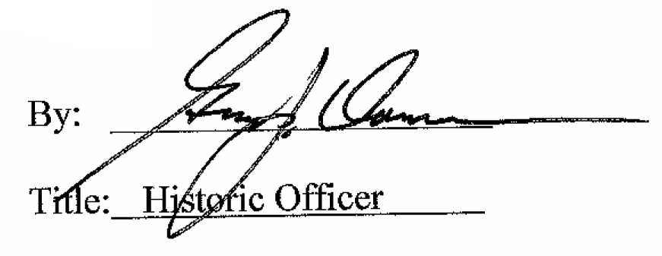

Date of Meeting: April 6, 2016

